**Sprint 2 Plan**

*Product:* $h0pLyf3 (Shopping List)

*Team:* Fantastic Five

*Sprint Completion Date:* Sunday, October 22, 2017

*Revision:* 1.0

*Revision Date:* October 23rd, 2017

*Goal:* We are working to allow users to log in to a publicly accessible server, create an account, add recipes, remove previously added recipes, remove ingredients from recipes, and create a shopping list based off of the recipes. This is the basic functionality we want, and the rest of the sprints will be adding extra functionality.

*Task listing:*

**User Story 1:** As a shopper, I want to be able to login to my account on a publicly accessible server so that I can use the application from anywhere.

* Move current code to server and change production settings (6)

**User Story 2:** As a shopper, I need to be able to add my own recipes to the website, as well as remove recipes I no longer use, so that my account is personalized to my taste.

* Create functionality to add/remove recipes on the backend (6)
* Create front-end to display recipes (2)
* Create front-end button to add recipes (2)
* Create front-end button to delete recipes (2)

**User Story 3:** As a shopper, I would like a shopping list to be generated from the recipes I have chosen so that I can save time creating a grocery list.

* Create backend to access recipes and pull ingredients (6)
* Create front-end button to create list (2)
* Create page view to select recipes for list (2)
* Create page view to display shopping list (2)

**User Story 4:** As a shopper, I would like to be able to remove ingredients I have from my shopping list, so that I don’t buy extra stuff I don’t need.

* Figure out how to remove ingredients from page without removing from database (6)
* Create front-end button to remove ingredients (6)

*Team Roles:*

**Connor Thurmond**: Product Owner, Developer

**Nikolai Chen:** Scrum Master, Developer

**Anna Lin:** Developer

**Andrew Gilchrist:** Developer

**Michael Tang:** Developer

*Initial task assignment:*

**Connor Thurmond**: As a shopper, I want to be able to login to my account on a publicly accessible server so that I can use the application from anywhere, Move current code to server and change production settings

**Nikolai Chen:** As a shopper, I would like to be able to remove ingredients I have from my shopping list, so that I don’t buy extra stuff I don’t need, Figure out how to remove ingredients from page without removing from database

**Anna Lin:** As a shopper, I would like a shopping list to be generated from the recipes I have chosen so that I can save time creating a grocery list, Create page view to display shopping list

**Andrew Gilchrist:** As a shopper, I need to be able to add my own recipes to the website, as well as remove recipes I no longer use, so that my account is personalized to my taste, Create functionality to add/remove recipes on the backend

**Michael Tang:** As a shopper, I would like a shopping list to be generated from the recipes I have chosen so that I can save time creating a grocery list, Create backend to access recipes and pull ingredients

*Initial burnup chart:*

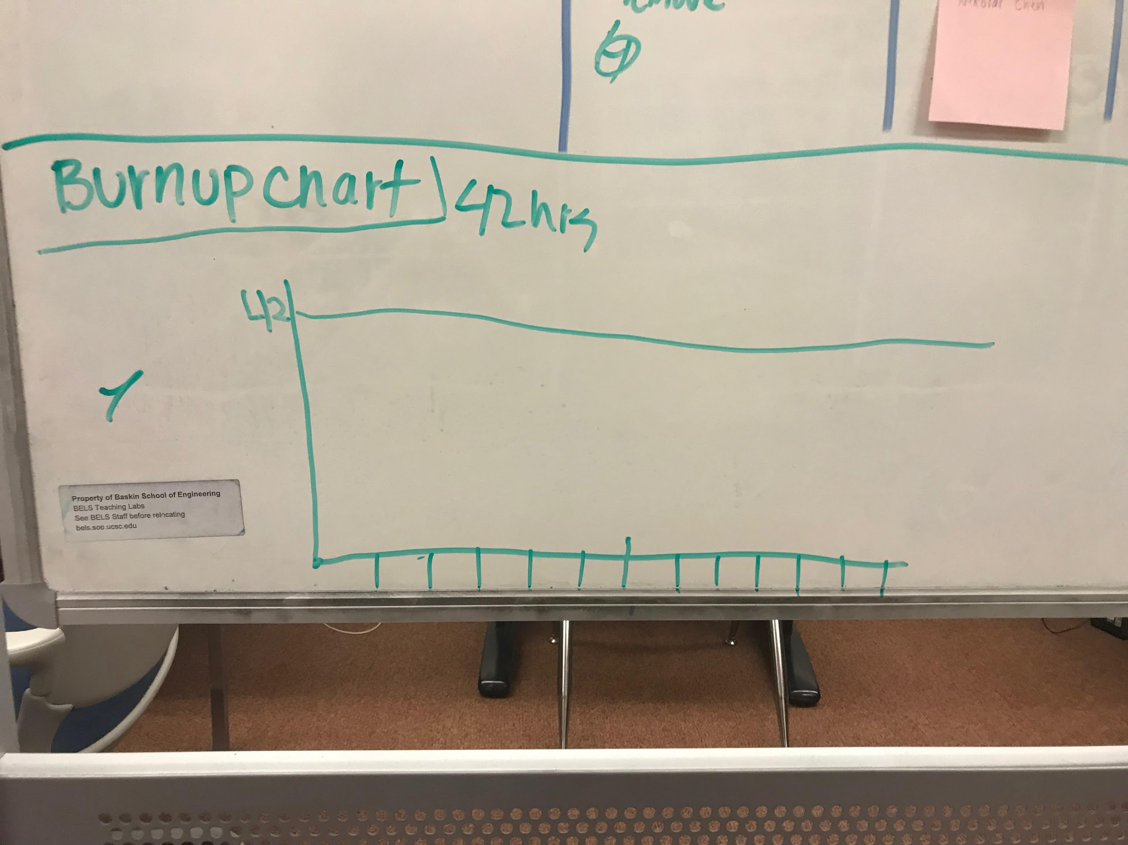

*Initial scrum board:*

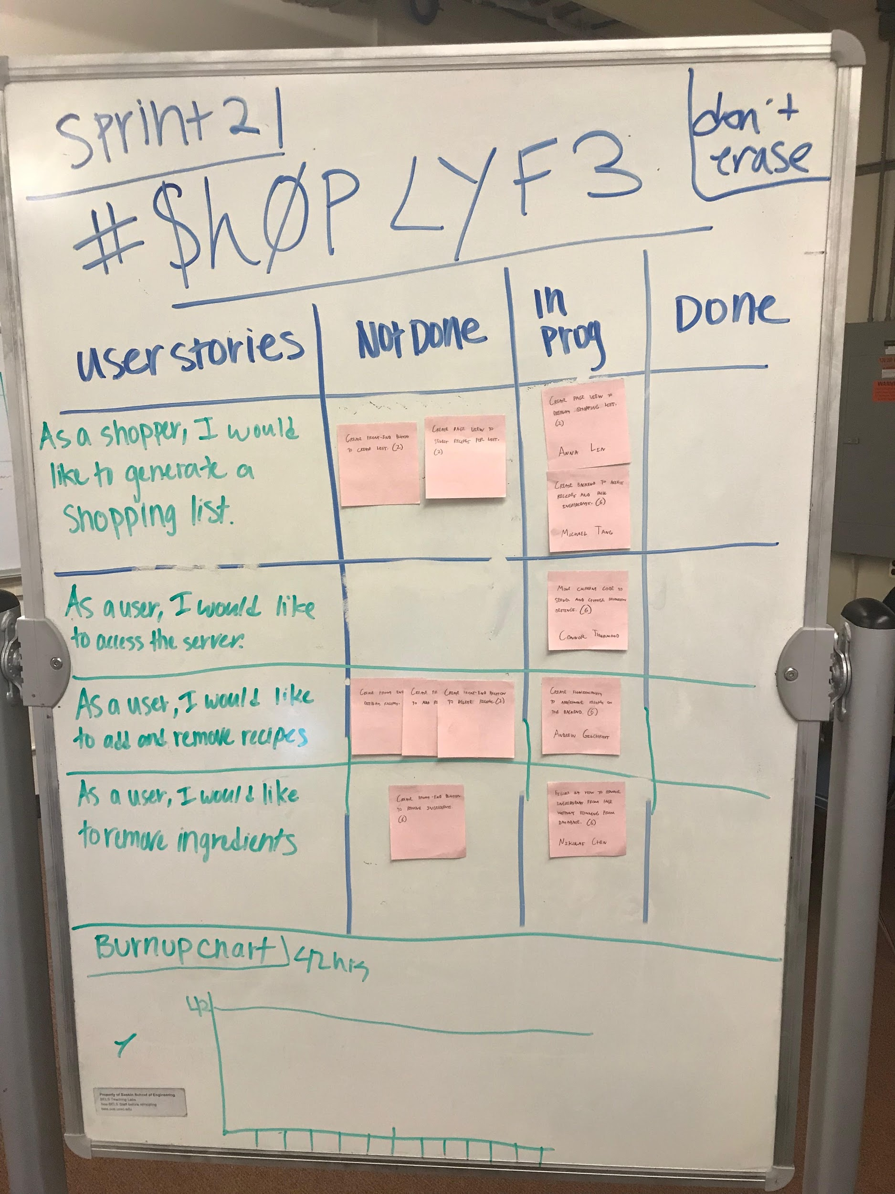

*Scrum times:* Our team will meet Monday and Wednesday from 10:30-12:00. We will meet with a TA on Thursday from 5:20 - 5:40.